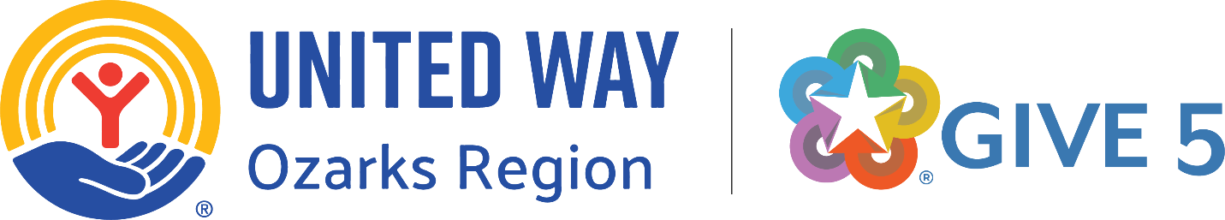

Give 5 Take Action Workshops:
Community Recommendations on Combating Misinformation and Disinformation

July 10, 2025

Introduction

The Springfield region is not immune from the increasing levels of misinformation and disinformation.

One can argue that the ability to quickly and easily spread misinformation and disinformation is an “upstream” cause of a variety of “downstream” effects – dropping levels of trust, increasing polarization of society, loss of faith in democratic processes and increasing threats to public health and economic systems. Positively impacting these “upstream” causes should yield dividends to strengthen our community. To do this requires civic engagement.

We planned an inaugural half-day, “Give 5 Take Action” intergenerational workshop whereby participants would hear from respected topic experts, discuss and debate concepts and strategies, then develop a set of recommendations for our community. We solicited applications from (a) Give 5 Program graduates (ages 60+) and (b) a wide variety of organizations with young professionals (ages 18-40) as employees or participants. We received 24 applications and accepted all 24 – 12 Give 5 graduates and 12 young professionals. Given the amount of work to be done, a second, shorter workshop was necessary to complete the recommendations. All participants completed a pre- and post-workshop survey. Survey results are included in this report. A more complete outline of the process is included in Appendix A of this report.

Given the breadth and depth of impact that misinformation and disinformation can have on communities, the first part of this report is devoted to providing an extensive background and context for the reader.

Background and Context

- “Information disorder is a crisis that exacerbates all other crises. When bad information becomes as prevalent, persuasive, and persistent as good information, it creates a chain reaction of harm . . . Mis- and disinformation have become a force multiplier for exacerbating our worst problems as a society. Hundreds of millions of people pay the price, every single day, for a world disordered by lies.” – Commission on Information Disorder – Final Report, Aspen Institute, November 2021, p. 1.

- “Misinformation is the inadvertent spread of false information without intent to harm, while disinformation is false information designed to mislead others and is deliberately spread with the intent to confuse fact and fiction. Identifying and combating the spread of mis- and disinformation is a major challenge in the increasingly complex information landscape of the 21st century.” – Brittanica, https://www.britannica.com/topic/misinformation-and-disinformation

- “The fundamental difference between misinformation and disinformation lies in intent. The key characteristic of misinformation is the lack of intent to deceive. Those who share misinformation typically do so in a naïve way, often unaware that the information they are passing on is false. The deliberate nature of disinformation makes it a more insidious and dangerous phenomenon than misinformation because it not only seeks to mislead but also to manipulate public perception and behavior in ways that serve the interests of the disinformation creators. The tactics used in disinformation campaigns often involve exploiting emotional triggers, such as fear, anger, or outrage, to bypass rational analysis and provoke a strong, immediate reaction from the audience. This emotional manipulation makes disinformation particularly difficult to combat, as it can entrench false beliefs and polarize communities.” – Overview of Misinformation and Disinformation, New America https://www.newamerica.org/future-security/reports/navigating-the-landscape-of-misinformation-and-disinformation/overview-of-misinformation-and-disinformation/#:~:text=Societal%20Impacts,exacerbate%20a%20public%20health%20crisis

- Misinformation and disinformation have profound and wide-ranging impacts on society today, affecting individuals, communities, and institutions alike.

- Erosion of Trust and Increased Polarization:
  - Distrust in institutions: The spread of false or misleading information erodes public trust in institutions such as the media, government, and the scientific community.
  - Political Polarization: Disinformation campaigns can exacerbate existing societal divisions and polarize communities by targeting specific groups and amplifying tensions.
  - Reduced Political Engagement: Misinformation can discourage political participation by creating confusion and cynicism about the political process.

- Threats to Public Health:
  - Vaccine Hesitancy: Misinformation about vaccines can lead to reduced vaccination rates, making it harder to achieve herd immunity and control infectious diseases.
  - Harmful Health Practices: False information about medical treatments or cures can lead individuals to adopt dangerous practices that jeopardize their health and well-being.
  - Delayed or Ineffective Treatment: Misinformation can cause people to delay seeking necessary medical care or to rely on unproven remedies, potentially worsening health outcomes.

- Undermining Democratic Processes:
  - Interference in Elections: Disinformation campaigns can be used to manipulate public opinion and influence election outcomes.
  - Weakening Democratic Institutions: By eroding trust and fueling division, misinformation can weaken the foundations of democratic societies.
  - Increased Social Unrest: Disinformation can contribute to social unrest and instability by inciting anger and distrust.

- Economic Costs:
  - Market Instability: False or misleading information can disrupt financial markets and negatively impact businesses.
  - Reputational Damage: Misinformation can harm the reputations of individuals, organizations, and brands.
  - Costs of Mitigation: Combating the spread of misinformation and disinformation requires significant resources, including fact-checking efforts and public awareness campaigns.

- Challenges to Social Cohesion:
  - Increased Hate Speech and Discrimination: Disinformation campaigns can target vulnerable groups and promote discriminatory views, contributing to social unrest and division.
  - Erosion of Civility: The spread of misinformation can make civil discourse more difficult and hinder constructive dialogue.
  - Increased Skepticism and Uncertainty: In an environment of pervasive misinformation, individuals may become overly cautious and question the authenticity of all information, making it harder to discern truth from falsehood.

- This increased level of misinformation and disinformation is being spread more easily, more broadly and more quickly than in the past, primarily due to social media.

- The increased level of misinformation and disinformation, plus the speed and breadth at which it is being spread, is contributing to the increased level of polarity within the citizenry.

- “While not a new problem, the emergence of our hyper-networked media ecosystem has accelerated the spread of mis- and disinformation. Prior to the Internet, mobile technologies, and social media platforms, people often relied on widely trusted sources such as local and regional media, national publications, and nightly broadcast news programs to receive information. Today we are hyperconnected. Anyone with a digital device holds the power to disseminate news and information. When consuming information this way, it can be hard to track claims to their original source or verify whether the information is based on fact. At the same time, information shared online is often free to consume, unlike fact-based articles and stories that trusted news sources publish. Today people are more reluctant to pay for news, as they can source what they perceive as quality information online. This dynamic has significantly impacted local news outlets—the most trusted source of news across all political affiliations.” – Brittanica, https://www.britannica.com/topic/misinformation-and-disinformation

- “Bad actors have leveraged this new information ecosystem by deliberately spreading disinformation to influence public opinion regarding vaccines, the COVID-19 pandemic, international affairs, political candidates, U.S. democracy, and other critical topics. These attempts at sowing distrust in our institutions have fueled vaccine hesitancy and skepticism, leading to major public health challenges. Disinformation has contributed to a rise of hate speech and political violence and initiated a revolving cycle of voter challenges and the introduction of voter suppression laws that have made it harder for voters—particularly older voters, voters of color, and voters with disabilities—to participate in democracy.” – Brittanica, https://www.britannica.com/topic/misinformation-and-disinformation

- “Some experts have warned that the rampant spread of mis- and disinformation has contributed to what they call a “post-truth” society, defined by Oxford Dictionaries as “relating to or denoting circumstances in which objective facts are less influential in shaping public opinion than appeals to emotion and personal belief.” – Brittanica, https://www.britannica.com/topic/misinformation-and-disinformation

- While media literacy skills can help people critically assess the accuracy of information, this influx of false information, matched with cognitive tendencies, is what drives sustainable false narratives. Research in cognitive science shows that when people repeatedly see or hear fabricated information, it can significantly distort their beliefs, even after being debunked. This is especially true if viewers see the information as novel, surprising, unique, or out of the ordinary. – Brittanica, https://www.britannica.com/topic/misinformation-and-disinformation

- People tend to seek out information that is consistent with their existing beliefs. Selecting and sharing information in such a manner in turn can lead to adverse effects. For example, preferentially seeking out and sharing negative information can lead to the social amplification of risks, and belief-consistent selection of information can lead to polarization. These processes in turn shape the information ecosystem, leading, for instance, to a proliferation of misinformation. In addition, frequent exposure to misinformation is claimed to hinder people’s general ability to distinguish between true and false information. – National Library of Medicine, National Institutes of Health, https://pmc.ncbi.nlm.nih.gov/articles/PMC10623619/#section20-17456916221141344

“More than any single action or implementable recommendation we could make, it is necessary for our government, civil society, and private sector leaders to prioritize, commit to, and follow-through on addressing the worst harms and worst actors and to invest in their own capacities to understand and respond to the problems we face together.” – Commission on Information Disorder – Final Report, Aspen Institute, November 2021, p. 16.

Community Recommendations

These are the recommendations for the Springfield-Greene County community from the Give 5 Take Action workshop participants:

- We should all look critically at our news sources.
  - Consult multiple sources and cross reference them to verify they are providing truth and facts. If you have a strong reaction to a “news” item, seek another source to corroborate the information.
  - Whenever possible, do a deep dive. Don’t just read the headlines; headlines are often sensationalized. Research and ensure your facts are correct before sharing information with others.
  - Have a healthy level of cynicism, but don’t be close-minded. Question what you read and hear.
  - Trust your gut instinct. If a news story seems odd to you, seek another reputable source to verify it is accurate.
  - Recognize all news sources have biases. Some national news sources seem to have the greatest bias. Learn where your news source(s) land on the “map” of news sources. Ad Fontes Media provides a Media Bias Chart at https://adfontesmedia.com/gallery/
  - Do not use social media as your primary news source unless an item is being posted by a legitimate news organization. Seek news from primary, reputable news sources.
  - Repetition does not equal truth. Just because someone repeats misinformation or disinformation over and over does not make it factual.
  - Approach your search for accurate news with self-reflection and humility.
  - Use fact-checking sites. Consult your local library. Here are some fact-checking websites recommended by the Harvard Library Research Guides:
    - PolitiFact.com – a project of the Poynter Institute for Media Studies; searchable by theme, truthiness, and more.
    - FactCheck.org – a project of the Annenberg Public Policy Center at U Penn
    - Global Fact-Checking Sites – a project of the Duke University Reporters' Lab
    - Fact Checker – the Washington Post's project, spearheaded by reporter Glenn Kessler, to investigate the truth behind the political rhetoric
    - Snopes – the oldest (b.1994) and largest fact-checking site online, widely regarded by journalists, folklorists, and readers as an invaluable research companion
    - Google Fact Check Explorer – powered by a claim review markup technology (which helps Google detect and display a fact check), this tool aggregates and thus helps users find fact checks by independent organizations from around the world

- Promote media literacy education for the community. Educating individuals on how to identify and evaluate information critically can help them become more discerning consumers of news and resist manipulation. Citizens must use discernment and critical thinking skills to be able to separate fact from fiction. This is a critical skill in today’s society.

- Heal polarity by conducting civil, face-to-face conversations with others who have a different viewpoint or ideology than you. Make a connection; build a bridge.
  - Listen openly.
  - Build trust.
  - [Note: Best practices for having these conversations were not identified within this workshop due to time limitations.]

- Take a break from social media. Seek news from trusted sources. Use fact-checking organizations to debunk false claims and provide accurate information (see the list of fact-checking sites above).

- Learn how social media algorithms work and that your feed is unique.
  - Educate yourself about why social media algorithms are pushing a unique, customized feed and specific information (or misinformation or disinformation) to you based on your history on that platform.
  - Educate yourself about why and how social media platforms spread misinformation and disinformation.
  - Think twice before liking/re-posting/sharing something on social media. Remember, when you re-post/share something on social media, it is the equivalent to you putting your “stamp of approval” on that item. Is it something you stand behind and can back up with facts?

- It is critical for our community to address the increasing levels of misinformation/disinformation. There is a high level of urgency to act.

- Observations of the Workshop Participants:
- Increasing misinformation/disinformation reduces civic engagement.
- Increasing misinformation/disinformation reduces levels of trust in the community.
- Increasing misinformation/disinformation has a negative impact on our democratic processes.
  - A person with low levels of trust in institutions is likely more susceptible to the spread of misinformation/disinformation.
  - Low levels of trust and the spread of misinformation/disinformation likely fuel each other.
- Misinformation/Disinformation spreads more quickly via social media. Social media algorithms appear to prioritize the spread of misinformation/disinformation.
- Increasing misinformation/disinformation has a negative impact on the levels of trust in experts and science.
- Increasing misinformation/disinformation has a negative impact on feelings of belonging.
- Increasing misinformation/disinformation has a negative impact on relationships with family, friends and neighbors.
- Increasing misinformation/disinformation has a negative impact on social connectedness, resulting in increased levels of loneliness and social isolation and alienating family and friends.
- Increasing misinformation/disinformation promotes feelings of grievance (and is more likely to be spread by individuals feeling high levels of grievance). Individuals who feel aggrieved are likely more susceptible to misinformation/disinformation.
- Increasing misinformation/disinformation likely helps promote hostile activism to create change (e.g., intentionally spreading disinformation, threatening or committing violence, damaging public or private property). Individuals in a “fight or flight” state are likely more susceptible to misinformation/disinformation.
- Increasing levels of misinformation/disinformation likely causes ripple effects within a community, resulting in various “downstream” symptoms.

Pre-Workshop / Post-Workshop Survey Results

Average age of participants:
- Give 5 Graduates: 70 (12 participants)
- Young Professionals: 31 (12 participants)
- Overall: 51 (24 participants)

Race/Ethnicity:
- White/Caucasian: 23
- Asian: 1

Gender:
- Give 5 Graduates: Female = 11; Male = 1
- Young Professionals: Female = 9; Male = 3
- Overall: Female = 20; Male = 4

- All participants considered themselves to be familiar with the concept of misinformation/disinformation before the workshop (8.35 out of 10) and after the workshop (8.28 out of 10).

- On average, the Give 5 graduates (older adults) consumed more than twice as much local news and information (9.42 hours/week) as the young professionals (4.42 hours/week).

- On average, the Give 5 graduates (older adults) consumed more than twice as much national/international news and information (11.17 hours/week) as the young professionals (5.54 hours/week).

- Asked to choose between two polar-opposite world views, all 24 participants chose the optimistic view (“It’s a big, beautiful world, mostly full of good people, and we must find a way to embrace each other and not allow ourselves to become isolated”).

- On average, the group is very concerned about the dropping levels of trust in all institutions (4.54 out of 5).

- On average, the group is very confident in themselves as a learner (9.08 out of 10).

- On average, the group is fairly certain that their particular political ideology is the right ideology (7.79 out of 10).

- On average, the older adults believed the young professionals were informed on local and national news at higher levels before (5.08 out of 7) and after (5.18) the workshop than the young professionals believed the older adults were informed on local and national news before (3.75) and after (4.58) the workshop.

- Relative to other scores, participants (both older adults and young professionals) rated “the process of developing recommendations for our community” lower (7.64 out of 10). This is likely due to the fact that the half-day workshop ran long and the participants did not have sufficient time to complete their work to develop collective recommendations for our community during that session. [Note: Because of this, the Give 5 Team hosted a second workshop and offered participants an opportunity to re-convene to complete their work to develop the recommendations within this report. The entire group was also provided an opportunity to review a draft of this report and provide comment/corrections.]

- When asked during the small-group, intergenerational breakout session how they discern what is true, the groups indicated they did not see a significant difference between the generations other than the fact the older adults (retired) had fewer time restrictions to cross-check sources.

- While both older adults and young professionals relied more heavily on “friends/family” as their primary news sources for local news, the mix was significantly different for national and international news, where older adults continued to rely most heavily on “friends/family,” but younger professionals relied most heavily on “podcasts.”

  - For young professionals, “podcasts” were the most accessed source (highest score) for national and international news. No older adult listed “podcasts” as a source for national and international news.

- Participants gave high ratings to the Give 5 Take Action workshop (8.67 out of 10), the effectiveness of the presentations by the “topic experts (9.00), the effectiveness of the intergenerational break-out group (8.67), and would recommend participation in a future Give 5 Take Action workshop to others (9.52).

- Participants felt the workshop increased their sense of responsibility to help improve their community (9.00 out of 10), felt their participation in the workshop made them feel more connected to their community (9.00), resulted in them meeting people other than those with whom they normally interact (9.46), and enjoyed participating in the workshop (9.75).

- 58% of participants (14 of 24) self-reported the workshop changed them.

- 67% of participants (16 of 24) self-reported the workshop prompted them to change or expand their primary news source(s).

Lessons Learned

- Hosting a workshop during regular working hours makes it difficult for some young professionals to attend due to work schedules. Of course, hosting a workshop in the early morning or evening would also be difficult for young professionals with children.

- The misinformation/disinformation topic is broad, has national/international implications, and can make it difficult to focus discussions and recommendations locally. In retrospect, hosting either a full-day workshop or a series of shorter workshops might have been a better strategy.

- Retirees have significantly more time to access local, national and international news compared to young professionals.

- The primary source for national/international news varied widely between the two groups of participants. Older adults relied most heavily on “friends/family,” but younger professionals relied most heavily on “podcasts.”

- Any future study should ensure there are participants who possess varying world views to ensure a more pessimistic worldview is represented in the discussion.

Sponsor Recognitions

This “Give 5 Take Action” workshop was made possible and was free to participants because of the generous support of our grantor and sponsors:

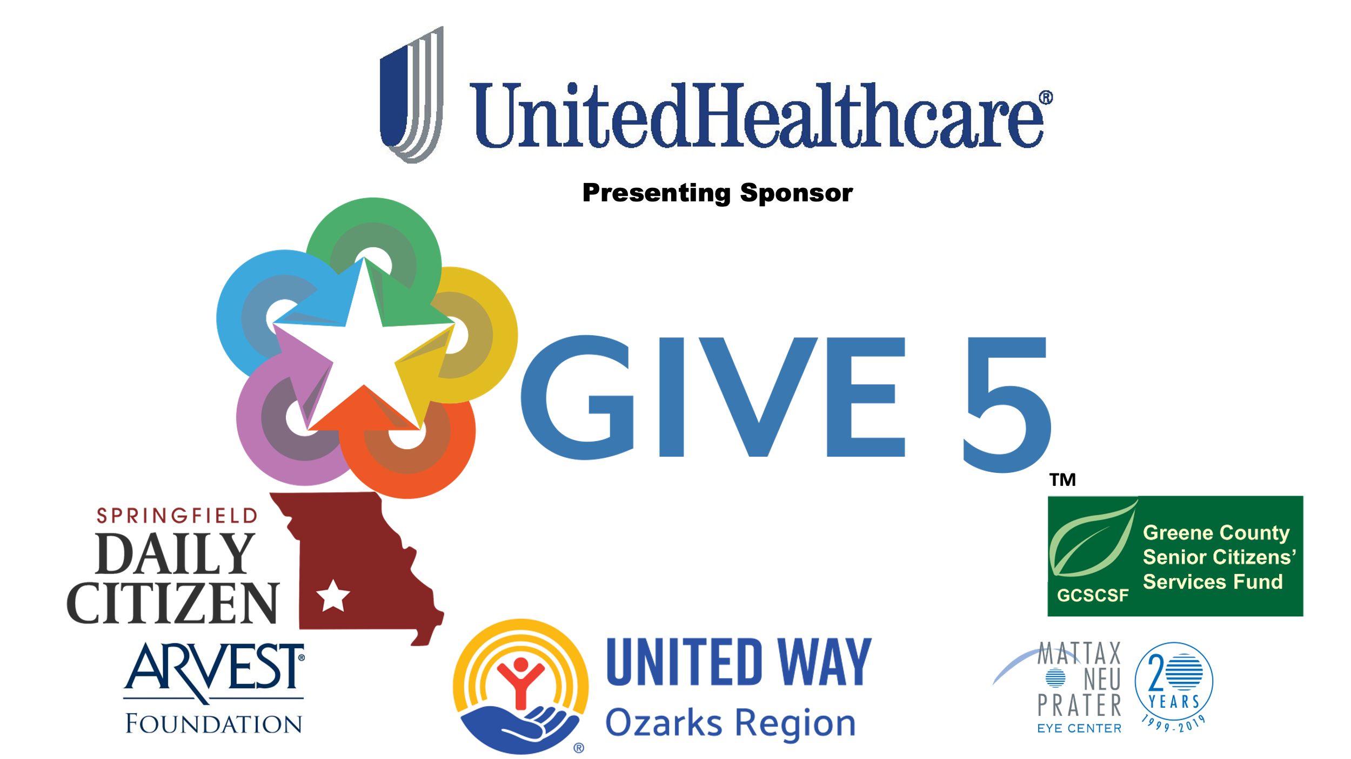

We would also like to thank the team at Gray Media Group of Springfield for allowing the workshops to be hosted in the KY3 Community Room.

Appendix A

The Workshop Process

- Hosted planning meetings with various topic experts. Decided on a half-day workshop format to be hosted in the KY3 Community Room.

- Workshop Goals:
  - Develop a set of “community guidelines” recommendations for consideration by community leaders
  - Encourage the application of recommended “solutions” to our local community (“how” and resources)
  - Increase personal awareness and feeling of empowerment
  - Collect “lessons learned”
  - Gauge interest in future intergenerational workshops

- Developed an online application, which included a battery of pre-workshop research questions.

- Solicited applications from all graduates of the Give 5-Springfield/Greene County program (approximately 350 graduates).

- Solicited applications from young professionals (age 18-40) via a variety of organizations and employers.

- Applications were received from twelve Give 5 graduates and twelve young professionals. All were notified of their acceptance into the workshop.

- Hosted the Give 5 Take Action Workshop #1 on March 11, 2025. Mayor McClure welcomed the group and stressed the importance of their work. Workshop participants heard from four topic experts:
  - Dr. Jonathan Groves, Professor and Chair of Communications Department, Drury University
  - Brian McDonough, Vice President and General Manager, Gray Media Group-Springfield
  - Cora Scott, Director of Public Information & Civic Engagement, City of Springfield
  - David Stoeffler, President and CEO, Springfield Daily Citizen

- Participants were divided into intergenerational work groups to discuss what they heard and respond to a set of questions. Participants ran out of time before completing their development of community recommendations. Almost all of the participants stayed an extra 30 minutes to make as much progress as possible before the organizers announced they would host a second workshop to complete the recommendations.

- The organizers proposed eight different date/time meeting options for Workshop #2. The date/time available by the most participants was selected.

- Give 5 Take Action Workshop #2 was hosted on April 15th, 3:00-5:00 and was attended by nine of the original twenty-four participants.

- The organizers assembled the participants’ feedback into a draft report and distributed the draft to all participants for review and feedback.

- The organizers updated the draft report based on participant feedback and developed the final version of the report for distribution.

